Lifecycle Event

Lifecycle Event – Voyager Mover - Employee and NEP

Event Configuration
Attribute | Value
Name | Voyager Mover - Employee and NEP
Type | Rule
Rule Name | Voyager Mover Event IdentityTrigger Rule

Event Rule Logic
The lifecycle event Rule is triggered when:

1. If any of the below attribute value has changed from previousIdentity and newIdentity
- Assignment_Business_Unit_ID
- Assignment_Department_ID
- Assignment_Job_Code
- Assignment_Location_Code

2. Assignment Effective Start Date value should be equal to Today’s Date.
This ensures the mover processing starts only when the following conditions are satisfied.

Additional Event Criteria
The lifecycle event is triggered when the following conditions are satisfied:
- Identity Attribute Inactive should be equal to False.
- If anyone of the below conditions satisfied :
  - WorkerType must be "C" and Assignment Status Type Code must be equal to "Active - No Payroll".
  - WorkerType must be "E" and Assignment Status Type Code must be equal to "Active - Payroll Eligible".
- Assignment Action Code must be equal to any of the below:
  - GLB_TRANSFER
  - ORA_POS_SYNC
  - POSITION_CHANGE
  - TRANSFER
This lifecycle event represents a mover process of an Contractor (C) and an Employee (E) and triggers the Voyager Employee and NEP Mover Workflow to update access, roles, and accounts accordingly.

Flow Chart
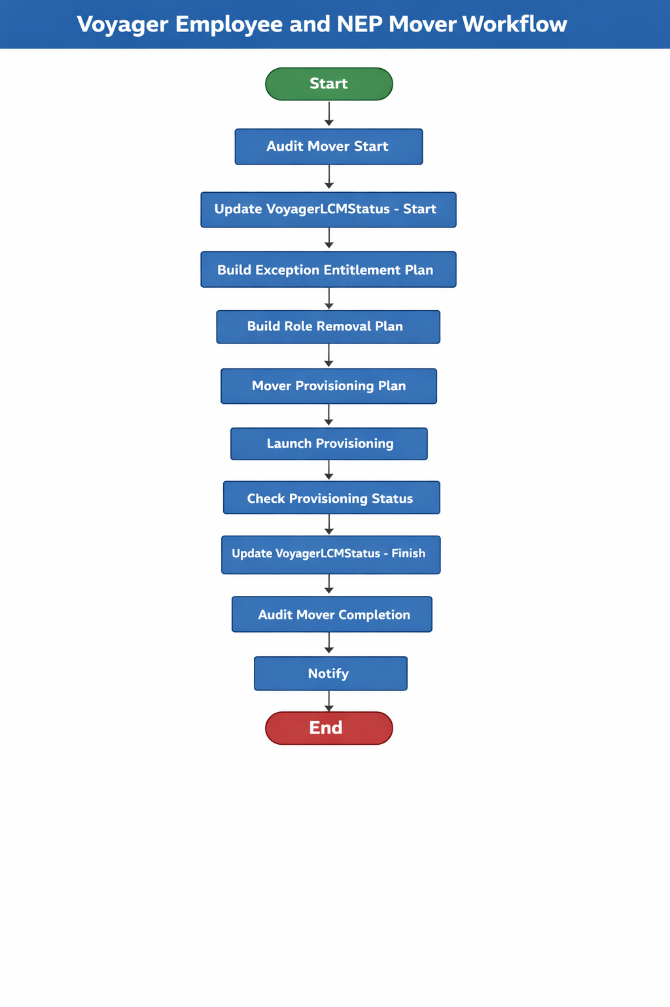

Step Summary

Voyager Employee and NEP Mover Workflow – Step Table
Step No | Step Title | Step Description
1 | Start | Initiates the Voyager Employee and NEP Mover workflow execution.
2 | Audit Mover Start | Creates an audit event indicating the mover process initiation based on the user’s workertype (Employee or NEP).
3 | Update VoyagerLCMStatus - Start | Updates identity attributes to mark the mover process as started and records the current date.
4 | Build Exception Entitlement Plan | Builds a provisioning plan to remove or retain exception entitlements based on mover configuration and application delete list.
5 | Build Role Removal Plan | Identifies removable business roles while excluding auto-assigned roles and prepares role removal requests.
6 | Mover Provisioning Plan | Prepares Active Directory account creation and updates existing AD accounts with primary or secondary domain indicators.
7 | Launch Provisioning | Executes provisioning using the Voyager LCM provisioning workflow and raises ServiceNow incidents for any provisioning errors or warnings.
8 | Check Provisioning Status | Reviews provisioning results and captures any errors or warnings into an error list for notification purposes.
9 | Update VoyagerLCMStatus - Finish | Updates identity attributes to indicate mover process completion and records the completion date.
10 | Audit Mover Completion | Logs a completion audit event based on the user’s workertype to confirm successful workflow execution.
11 | Notify | Sends a mover completion notification to the user’s manager including any provisioning error details if present.
12 | End | Marks the successful completion of the mover workflow process.

Workflow Description

Voyager Employee and NEP Mover Workflow

Workflow Steps

1. Start
This step marks the initiation of the Voyager Employee and NEP Mover Workflow.

2. Audit Mover Start
An audit event is generated to record the initiation of the mover process.
- For identities with Workertype = “C”, create an audit event with the name:
“Initiated - NEP Mover Event Started.”
- For identities with Workertype = “E”, create an audit event with the name:
“Initiated - Employee Mover Event Started.”
Upon successful audit creation, the workflow transitions to “Update VoyagerLCMStatus - Start.”

3. Update VoyagerLCMStatus - Start
Update the following identity attributes:
- voyagerLCMStatus: Set to “Mover Started.”
- voyagerLCMDate: Set to the current system date.
After updating the attributes, proceed to “Build Exception Entitlement Plan.”

4. Build Exception Entitlement Plan
This step constructs a provisioning plan to manage entitlement exceptions based on configuration data.
- Custom Object: “Voyager Mover Configuration.”
- Entitlements to Retain:
  - UKG: Initial Role
  - Duo Groups: based on Custom Object “Ascension-Custom-AD-DomainMapping”
- Applications Marked for Deletion:
  - EPM Cloud EDMCS,
  - EPM Cloud Planning,
  - EPM Cloud FCCS,
  - EPM Cloud ARCS,
  - EPM Cloud EPCM
Processing Logic:
- Retrieve Delete Application List and Retain Entitlement List from the custom object.
- Iterate through all exception entitlements assigned to the identity.
- Determine the application name associated with each entitlement.
  - If the application is present in the Delete Application List, create an account request to delete the application account.
  - If the application is not present in the delete list, create an account modification request to remove the entitlement only if it is not part of the retain entitlement list.
- Aggregate all generated account requests into a single ProvisioningPlan.
Upon completion, proceed to “Build Role Removal Plan.”

5. Build Role Removal Plan
This step identifies and prepares role removal requests.
Processing Logic:
- Retrieve all requested roles currently assigned to the identity.
- Exclude auto-assigned roles from the removal scope.
- Identify IT roles that must be retained because they are either:
  - Required for subsequent role assignments, or
  - Expected to be removed as part of business role removal processing.
- Generate account requests to remove all applicable roles and append them to the ProvisioningPlan.
- Only detected IT Roles which are not part of any Business roles are deleted.
Then transition to “Mover Provisioning Plan.”

6. Mover Provisioning Plan
This step prepares Active Directory account provisioning and attribute updates.
Processing Logic:
- Retrieve the identity object and determine its domain value.
- Load Active Directory domain-to-OU mapping configuration from a custom object.
- Iterate through the identity’s existing account links and identify Active Directory connector accounts.
- Update the msExchExtensionAttribute35 attribute on existing AD accounts:
  - Set to “Primary” for the target AD domain.
  - Set to “Secondary” for other AD domains.
- If an account does not exist for the target/primary Active Directory application, create a new account request.
Return the updated ProvisioningPlan containing all required AD account creations and attribute updates.
Proceed to “Launch Provisioning.”
Please Note : If a user’s Market value changes and the new Market is mapped to a different Active Directory (AD) domain, the existing AD account will be designated as Secondary, and all Duo groups will be removed from the Secondary AD account.
Furthermore, the newly created AD account will be designated as Primary, and the corresponding Duo groups associated with the Primary AD account will be assigned to the user.

7. Launch Provisioning
Execute provisioning using the Voyager LCM Provisioning Workflow.
Post-Provisioning Handling:
- If errors or warnings are detected in the ProvisioningResult of the ProvisioningProject, create a ServiceNow Incident Ticket containing:
  - Request details
  - Error or warning information
Then move to “Check Provisioning Status.”

8. Check Provisioning Status
Retrieve the ProvisioningResult from the ProvisioningProject.
- If any errors or warnings are present, capture them in an errorList map.
- This map will later be used in email notifications.
After processing, transition to “Update VoyagerLCMStatus - Finish.”

09. Update VoyagerLCMStatus - Finish
Update identity attributes as follows:
- voyagerLCMStatus: Set to “Mover Completed.”
- voyagerLCMDate: Set to the current system date.
Then proceed to “Audit Mover Completion.”

10. Audit Mover Completion
Create a completion audit event using the identity’s retrieved attributes.
- For Workertype = “E”, audit name:
“Completed - Employee Mover Event Finished.”
- For Workertype = “C”, audit name:
“Completed - NEP Mover Event Finished.”
After audit logging, transition to “Notify.”

11. Notify
Send a Mover Completion Notification to the identity’s manager.
- If any errors or warnings were captured in the errorList, include them in the email notification content.
Upon completion, proceed to “End.”

12. End
Marks the successful completion of the Voyager Employee and NEP Mover Workflow.

